CS3506 - Wireshark Lab 3: ICMP and Fragmentation Lab.

In this lab, we’ll explore several aspects of the Internet Control Message Protocol (ICMP):
- ICMP messages generating by the ping program;
- ICMP messages generated by the traceroute program;
- ICMP responses generated by “false” UDP and TCP probes using the traceroute program;
- The format and contents of an ICMP message.

Ensure your PC is running Linux and remember that you have to run Wireshark as the administrative user, so at the command line type “sudo wireshark” (without the quotation marks). When prompted for a password please enter your own password. You may first also need to run “xhost +” to ensure that the X Window System allows Wireshark access to the display.

1. ICMP and Ping
Let’s begin by capturing the packets generated by the Ping program. Recall that Ping is a simple tool that allows anyone (for example, a network administrator) to verify if a host is live or not. The Ping program sends a packet to the target IP address from the source host; if the target is alive, it responds by sending a packet back to the source host. As you might have guessed (given that this lab is about ICMP), both of these Ping packets are ICMP packets.

We did the following:
Started up Wireshark, and began the packet capture.
- At the command line we typed “ping –c 10 www.ucc.ie”. The argument “-c 10” indicates that 10 ping messages should be sent (See Figure 1).
- When ping terminated, we stopped the packet capture in Wireshark and saved the captured packets.

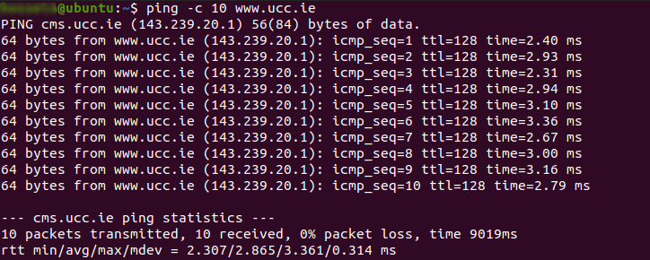
Figure 1. Running ping command.

As you see from Figure 1, at the end of the experiment the command window showed that the source ping program sent 10 query packets and received 10 responses. Note also that for each response, the source calculates the round-trip time (RTT). Note the summary statistics produced by ping and include in “Submission” sheets.

Download ping_ucc.pcap from the Canvas page and open it in your Wireshark. Enter “icmp” in the Wireshark filter display window and study the Wireshark output. Considering that no ping requests/responses were lost, the packet listing shows 20 packets: the 10 ping queries sent by the source and the 10 ping responses received by the source. Also note that the source’s IP address is in the UCC subnet 143.239.0.0/16, as is the destination address.

Now let’s zoom in on the first packet (sent by the client). We see that the IP datagram within this packet has protocol number 01, which is the protocol number for ICMP. This is what declares the payload of the IP datagram to be an ICMP packet. Observe that this ICMP packet is of Type 8 and Code 0, a so-called ICMP “echo request” packet. Also note that this ICMP packet contains a checksum, an identifier, and a sequence number.
- Now answer questions 1.1 and 1.2
2. ICMP and Traceroute

We continued by capturing the packets generated by the traceroute program. The traceroute program can be used to figure out the path a packet takes from source to destination. The program sends the first packet with TTL=1, the second packet with TTL=2, and so on. Recall that a router will decrement a packet’s TTL value as the packet passes through the router. When a packet arrives at a router with TTL=1, the router reduces it to 0 and sends an ICMP error packet back to the source.

We will now study the differences when using ICMP and TCP probes. We did the following:
- Started up Wireshark.
- Ran “sudo traceroute -n -I -m 5 www.ucc.ie”. “-n” disables intermediary node hostname lookup, “-I” forces ICMP probes and “-m 5” sets the maximum TTL to 5. This command will send 3 packets with TTL=1, 3 packets with TTL=2, and 3 packets with TTL=3 and so on at once.
- Ran “sudo traceroute -n -T -p 34567 -m 5 www.ucc.ie”. “-T” forces TCP probes, and “-p 34567” sets the destination port to 34567. TCP probes have the SYN flag set.
- Ran “sudo traceroute -n -T -p 80 -m 5 www.ucc.ie”. “-p 80” will send the probes to destination port 80, which is the default http port a web server usually operates on, and www.ucc.ie is a web server (See Figure 2).
- When traceroute terminated, stopped the packet capture in Wireshark.

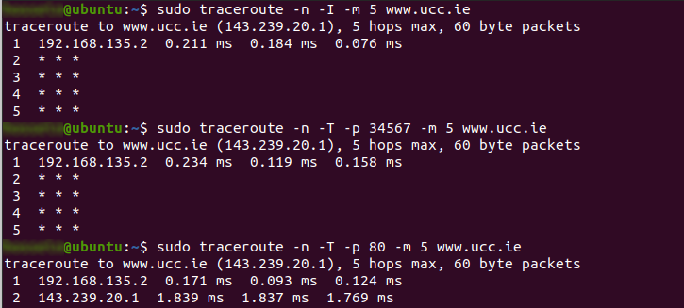
Figure 2. Running traceroute command.

Download traceroute_ucc.pcap from the Canvas page and open it in your Wireshark. In Wireshark, type “ip.host == 143.239.20.1”. Make sure that you click the Apply button. The filter will clear up the display for you, allowing only the packets sent or received from the destination IP to be displayed. If the destination IP is wrong, the filter will hide all packets, or display irrelevant traffic.

Notice that for each TTL value, the source sends three probe packets. traceroute displays the RTT for probe packets, as well as the IP address (and possibly the name) of the router that returned the ICMP TTL-exceeded message. As the processing of messages is more CPU intensive and complicated than forwarding for routers, you might see the responses of the destination host arrive before the responses from the intermediary routers.

- Now answer questions 2.1-2.4

These notes are based on an original © Kurose & Ross 2009

